Project Design Phase
Solution Architecture

Date | 29 -11-2025
Name | Yakshagaraj A G
Project Name | Online Bookstore
Maximum Marks | 4 Marks

Solution Architecture:
The solution architecture for the Online Bookstore ensures a scalable, secure, and user-friendly platform for browsing, searching, reviewing, and purchasing books.
The system supports smooth catalog management, fast UI performance, and seamless shopping workflow for users while providing admin-level control for inventory and book listings.
Key Architectural Goals
- Fast and intuitive user experience
- Secure login and transactions
- Efficient book search and filtering
- Organized and reliable inventory management
- Mobile-responsive design
- Scalable backend to support large catalogs and user traffic

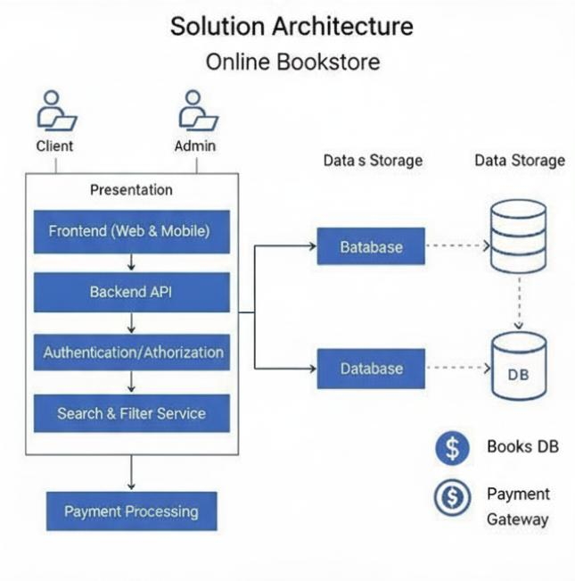
Solution Architecture Diagram:

